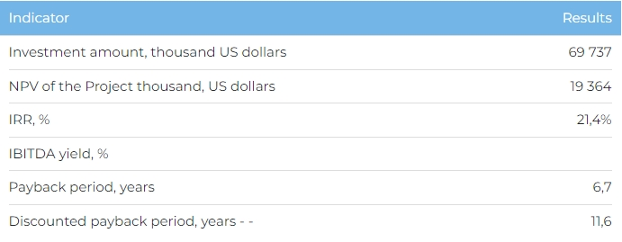
Products
When design capacity is achieved in 2029, plant production levels will be as follows: ferrous metal scrap – 2,700 tonnes, non-ferrous metal scrap – 675 tonnes, wastepaper – 6,075 tonnes, glass fragments – 5,400 tonnes, PET bottles – 2,025 tonnes, PE granules – 8,750 tonnes, strapping tape – 2,000 tonnes, compost – 100,000 tonnes, RDF-fuel – 108,000 tonnes.
All product is due to be sold domestically.
Project
This investment project envisages the creation of a techno-eco park with capacity to process up to 500 thousand tonnes of solid domestic waste per year in Almaty Oblast’s Ili District. The techno-eco park will incorporate a waste processing with sorting lines, waste processing zones, and production lines to create alternative fuel, as well as 3 stations between the nearest villages in the Ili District for transferring waste.
The Spanish company IMABE IBERICA S.L., German companies HERBOLD, NAUE and STARLINGER, Italian company SOREMA & PREVIERO, as well as Austrian company EREMA have been chosen to supply equipment for the techno-eco park and waste transfer stations. A search is being carried out together with the Almaty Oblast Akimat to find a site for the plant.
Company
Recycle Management Company LLP was founded in 2020 to realise the Project to create a techno-eco park. Under the leadership of the Chairman of the Supervisory Board, 3 waste processing plants were built in Kazakhstan.
Market
- At the end of 2022, Almaty and Almaty Oblast generated 452 thousand tonnes and 429 thousand tonnes of solid domestic waste, respectively. Solid domestic waste processing and reuse were at 18% in Almaty and 17% in Almaty Oblast. The Almaty development programme for 2025 and average prospects for 2030 plan to increase the share of solid domestic waste processed to 32% in 2025 and 80% in 2030, and reduce waste generation at source by 2030 to 10%.
What is the attractiveness of the project?
- Advantageous location. Having the techno-eco park based in Almaty Oblast will help cover Almaty agglomeration consumer markets, where over 10 large and 38 medium-sized companies produce paper products, glassware, plastic items, and nonferrous metal building structures. Project location will also ensure access to feedstock. The Almaty agglomeration generated over 800 thousand tonnes of solid domestic waste in 2022, ensuring sufficient reserves to feed a waste processing plant at full capacity.
- Ecological aspects. Only 25.4% of solid domestic waste in Kazakhstan is currently processed, with the majority of it, roughly 74%, sent to landfill sites. In 2022, Kazakhstan recycled and buried a total of 2.6 million tonnes of waste, of which Almaty Oblast was responsible for 408 thousand tonnes. An effective solid domestic waste processing programme will help prevent mixed waste entering landfill sites and unsanctioned dumps, reduce the size and area of solid domestic waste burial sites, at the same time reducing ecological risks.
Investment proposal
The Project requires an investment of 69,737 thousand USD (at the rate of 449.2 tenge), of which:
- 80% (55,790 thousand USD) - debt financing from JSC Zhasyl Damu;
- 20% (13,947 thousand USD) – investor participation.
The proposed financing structure and state support measures are indicative. The final financing structure and Project interests will be determined based on the results of negotiations with the investor.
